Exp No: 18
GENERATION OF PWM USING TIMER INTERRUPT
Code:
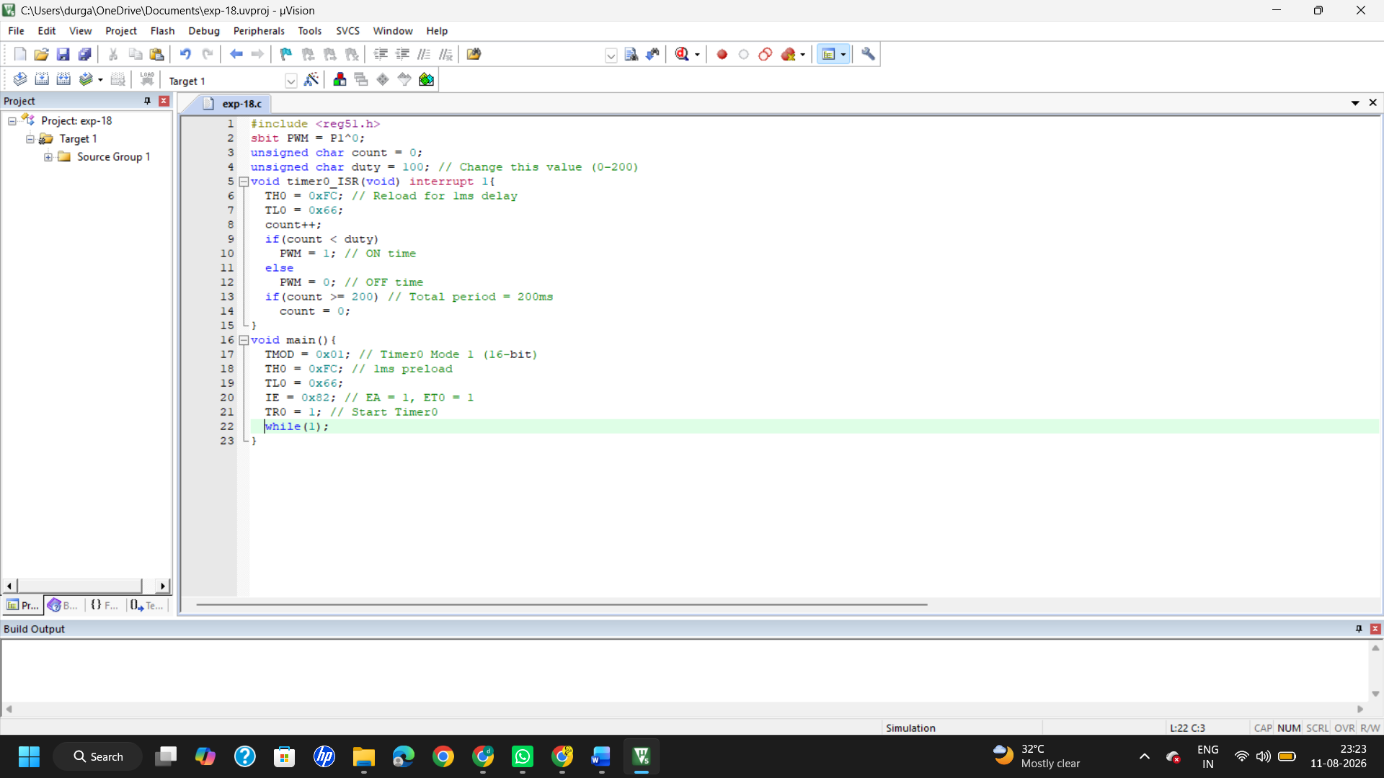
Output:
50% duty cycle:
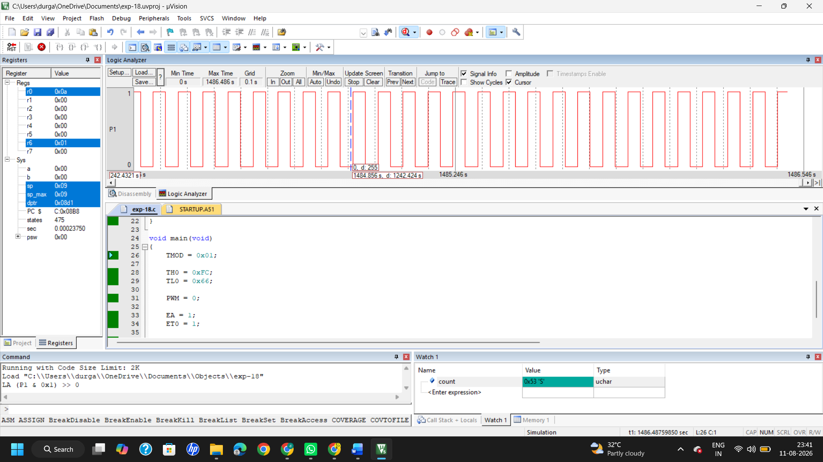
25% duty cycle:
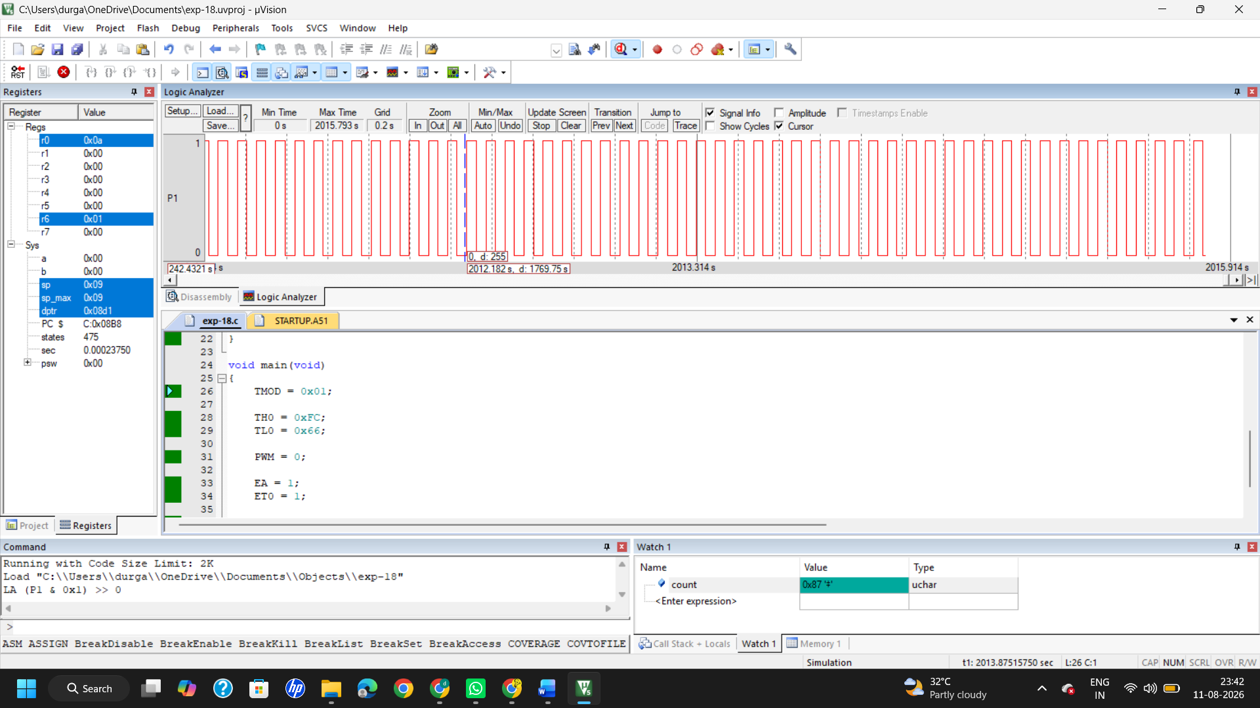

75% duty cycle:
